Installing the Ef core packages and adding creating the initial migration:
Please note that an error was found because of OS system incompatbilies. Im using MacOS, and ASP.NET is deprectared and no longer supported in macOS
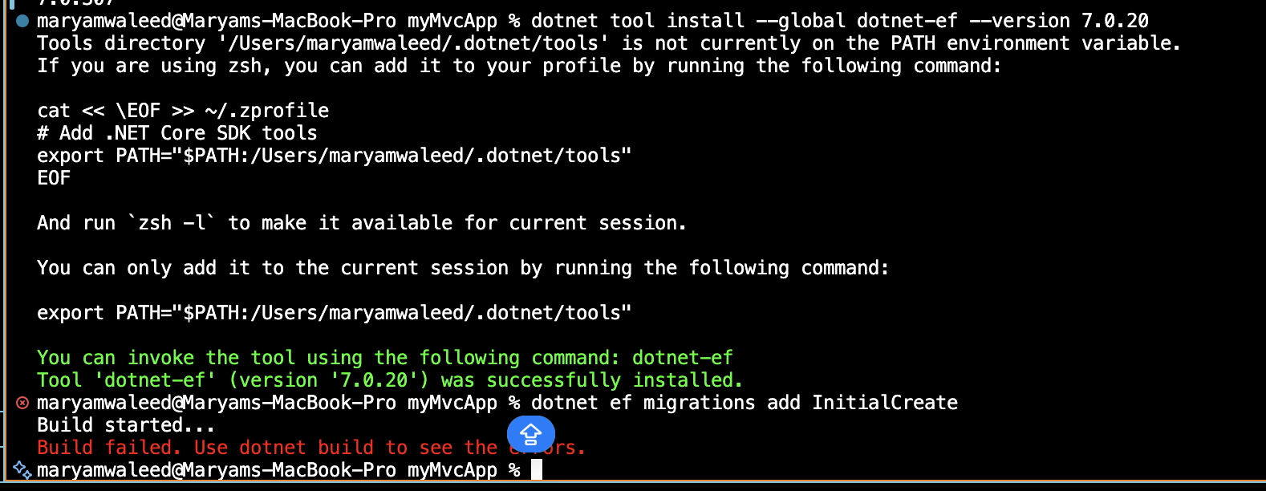

Added Swagger UI in the Dev mode.

